|  |  |
| --- | --- |
|  |  |

Pygame Assignment  
Michele Pipicelli  
St Michaels College – Stage 1 Digital Technologies

# Introduction

In this Pygame Assessment I decided to create a Space Invaders-esque 2D shooter game. I decided to create this as it is a relatively simple game that gave me the ability to use *classes, functions, a score, and a win and loss* screen. The game allows the player to control a spaceship left and right using the A and D keys and shoot a missile using Space at randomly spawning enemies which also fire back at the player every two seconds. The win condition of the game is to reach a score of 2000 at which point all enemies stop spawning which will display a win screen. The loss condition of the game is being damaged enough by enemies to reach a health value of less than 0, at which point a loss screen will display.

# Flowchart

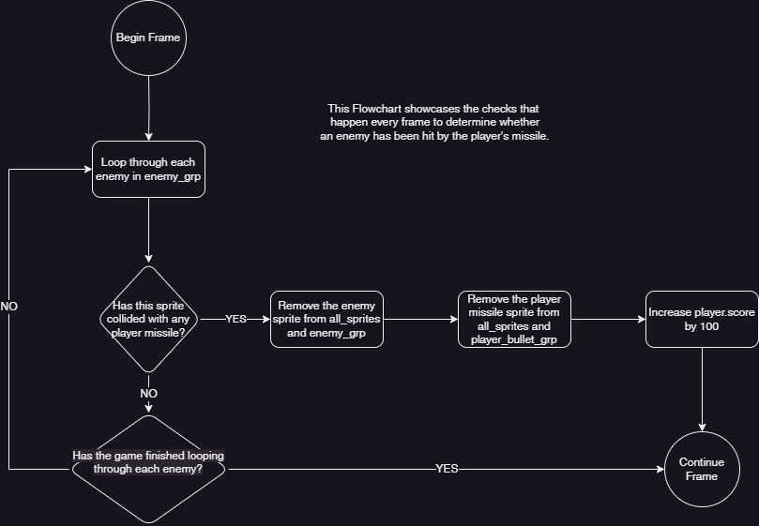

# Part 2

In Part 2 of my game, I have improved upon my initial game by adding features, sounds, improving upon code quality, and win and lose conditions. The features I have implemented include making enemies pop back up the top of the screen upon going off screen, and a displayed health bar and score. Moreover, I have utilized inheritance with my classes to improve upon the code quality. I accomplished this by making a base Sprite class which extends the *pygame.sprite.Sprite* class and had it include the basic variables and functions every class includes such as *move()*, *draw()* and *swap_image()*. I did this to avoid including duplicate code in classes and improve readability. Furthermore, I have added a sound for when the player shoots. In addition, I have included a win and lose condition for when the player’s health hits 0 to indicate a loss, and the player destroying enough ships to reach a score of 2000 for a win condition. Overall, I have improved upon my initial game by adding shoot sounds, win and loss conditions, improving upon code quality with inheritance, and making enemies pop on the other side of the screen when going off screen.

# Diagram

# y

**MOVEMENT**

**ENEMY BULLET**

**PLAYER BULLET**

**ENEMY**

**PLAYER**

# Key

Health:

Score: 2000